GENERAL HOUSE RULES AND OTHER INFO
YOUR HOST IS SZILVIA

- +356 79 35 17 07 (by daylight)
- hello@wh-malta.com (by darkness)
CHECK IN / CHECK OUT

- Check in time is after 1 pm.
- Check out time between 8 am and 10 am.
- Check out before 8 am we do in the evening before.

TOURIST TAKS  MALTA | - € 0,50 per guest per night  - To be payed at the check in
EXTRA GUESTS

- Only the confirmed guests are allowed to be in the accommodation
- Additional guest(s) has to be announced to your host before they enter the accommodation
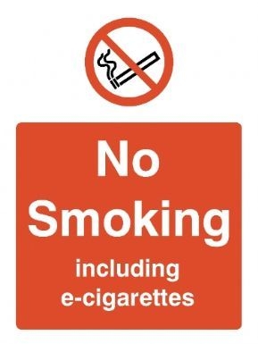 | NO SMOKING  - It is strictly forbidden to smoke, also not with an electronic device.  - This prohibition applies the entire building. So inclusive staircases, halls, balconies, roof terraces. Etc.  - Smoking is only allowed outside in the street.
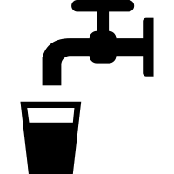 | DRINKING WATER  - Don’t drink water from the taps.  - For cooking and teethbrushing you can use the tap.  - Every supermarket sells drinkingwater in bottles.
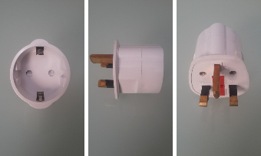 | ELECTRICITY  - In malta there is 220 volt on the electricity network. The socket in the wall has 3 holes.  - We provide some of the special plugs. If you need more you can buy them in almost every supermarket.
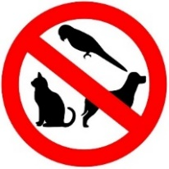 | ANIMALS  - Animals of any kind are not allowed in the apartment.
USING THE ROADS

- All traffic drives on the lefthand side of the road.
- Take into account holes in the road surface.

